Iterative Methods for Poisson and Laplace Equations

The Poisson equation is:

$$∇^{2}u=f$$

The Laplace equation is the homogeneous Poisson equation:

$$∇^{2}u=0$$

We only consider the two-dimensional Poisson equation

$$∇^{2}u=\frac{∂^{2}u}{∂x^{2}}+\frac{∂^{2}u}{∂y^{2}}=f\left(x,y\right)$$

We will compare the various iterative methods to solve the Poisson equation using the following example

$$\frac{∂^{2}u}{∂x^{2}}+\frac{∂^{2}u}{∂y^{2}}=2\left[x\left(x-1\right)+y(y-1)\right]$$

The boundary conditions are set as $u=0$ along all four sides of $1×1$ square domain. This problem has an analytical solution given by the following expression:

$$u\left(x,y\right)=xy\left(x-1\right)\left(y-1\right)$$

Discretization

Assuming $Δx=Δy=h$, we can write the discretised Poisson equation in the following manner:

$$u_{i+1,j}+u_{i-1,j}+u_{i,j+1}+u_{i,j-1}-4u_{i,j}=f_{i,j}h^{2}$$

Rearrange in the form of a recurrence relationship:

$$u_{i,j}=\left(1-ω\right)u_{i,j}+\frac{ω}{4}\left(u_{i+1,j}+u_{i-1,j}+u_{i,j+1}+u_{i,j-1}-f_{i,j}h^{2}\right)$$

By choosing the values of the terms at certain iterations, we can form all the iterative schemes that we will discuss later. In all the cases, we will take $u^{0}=0$.

Jacobi Iteration Method $ω=1$

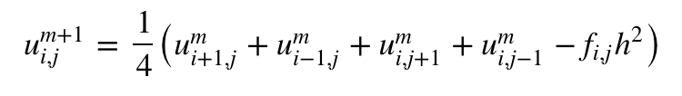

Gauss-Seidel Iteration Method $ω=1$

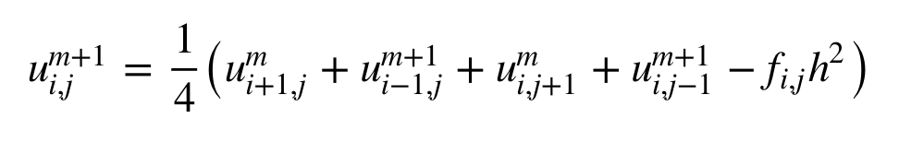

Successive Over-Relaxation [SOR[ Iteration Method $1<ω<2$

